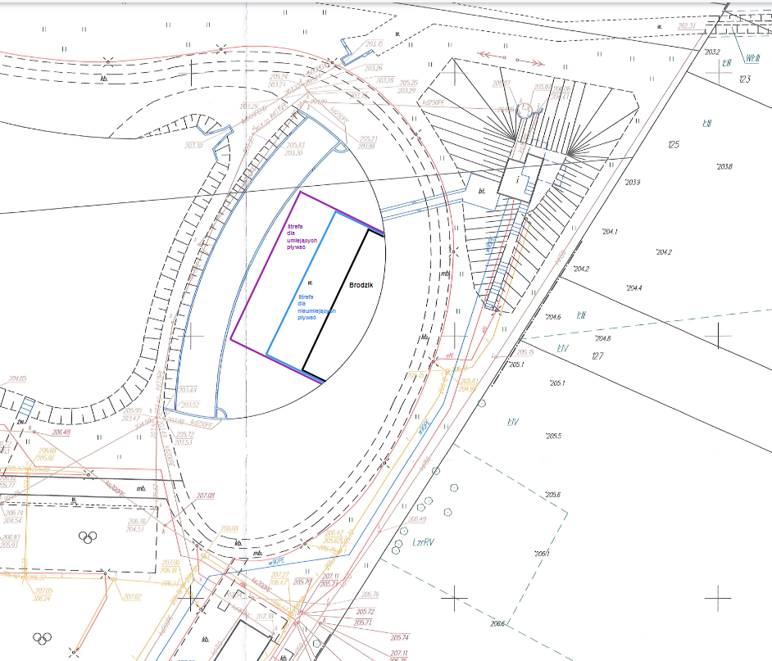

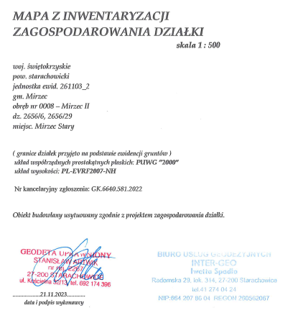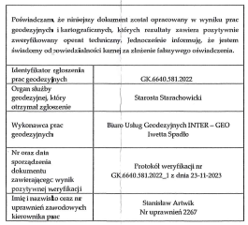

|  |  |
| --- | --- |
| **X** | 365570.68 |
| **Y** | 644099.04 |

|  |  |
| --- | --- |
| **X** | 365519.15 |
| **Y** | 644077.34 |

|  |  |
| --- | --- |
| **X** | 365540.92 |
| **Y** | 644105.13 |